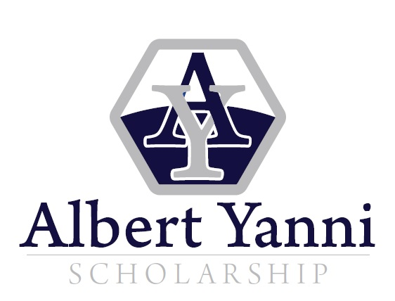
2022
PURPOSE:
The Albert Yanni Scholarship provides high quality career and technical education (CTE) students an opportunity to pursue advanced education and/or training related to their career aspirations.

GENERAL INFORMATION: Scholarships of $2,000.00 each will be awarded to students selected by a committee of West Virginia Department of Education (WVDE) personnel. Applicants selected must present proof that they have maintained their eligibility requirements before awards are presented.

HIGH SCHOOL APPLICANT MINIMUM REQUIREMENTS:

- Each applicant must be a secondary student currently enrolled in a public school in the state of West Virginia who will have completed all graduation requirements by the end of the current school year.
- Each applicant must have a cumulative (9-12) attendance rate of 85% AND a cumulative (9-12) minimum GPA of 3.0.
- No applicant may have a final semester grade below a C in grades 9 – 12.
- Each applicant must have completed or be on track to complete no less than the four required courses for a state approved CTE program of study in accordance with WVBE Policy 2520.13.
- Each applicant must be planning to pursue postsecondary education in a career field related to his/her secondary career technical program of study.
- Each applicant must be registered with, or accepted by, an accredited post-secondary institution or technical center in a technical certificate or degree program.

HOME SCHOOLED APPLICANT MINIMUM REQUIREMENTS:

- Each applicant must have completed at least four units in a single, approved career technical program of study.
- Each applicant must be planning to pursue postsecondary education in a career field related to his/her secondary career technical program of study.
- Each applicant must be registered with, or accepted by, an accredited post-secondary institution or technical center in a technical certificate or degree program.
- Each applicant must have taken the TASC and passed with a minimum score of 550 AND provide a copy of said score.

SELECTION PROCESS:

All eligible applicants will be rated by the WVDE committee in the following areas:

- Personal Information Form completion (5 points possible)
- Eligibility Form completion (5 points possible)
- Consent Form completion (5 points possible)
- Recommendations from an academic teacher (15 points possible), a career technical teacher (15 points possible), and a peer (15 points possible).
- Awards, honors and school and community involvement (15 points possible).
- Scores on a 500 word essay (25 points possible).
- Ties will be broken by class rank or GPA.

The applicants with the highest numerical scores will not automatically be selected. An effort will be made to distribute the awards geographically and across program areas.

APPLICATION PROCESS:
- New for 2022, the application process is completely online.
- The application must be completed in its entirety. If an item or question does not pertain, please enter N/A.
- Do NOT submit transcripts, resumes, copies of awards, news articles, thank you letters or any materials.
- Application must be submitted no later than April 15, 2022.
- For additional questions, contact:
  - Nathan Taylor at 304.558 or e-mail questions to Nathan at netaylor@k12.wv.us
- Letters or e-mails of notification will be mailed on or before May 1, 2022.
- Completed online forms will be submitted by the person completing the form.

APPLICATION LINKS:
- The student applicant will complete the Student Yanni Scholarship Form.
- A school official will complete the School Official Yanni Scholarship Form.
- The student applicant will select an academic teacher to complete the Academic Teacher Yanni Scholarship Recommendation Form.
- The student applicant will select a technical instructor to complete the Technical Instructor Yanni Scholarship Recommendation Form.
- The student applicant will select a peer who has been in one or more class with the student applicant to complete the Peer Yanni Scholarship Recommendation Form.

REASONS FOR DISQUALIFICATION:

- Use of a previous year’s application: Only the current application (2022) will be accepted. Use of any other application will be reason for disqualification.
- Incomplete Forms: ALL INFORMATION ON ALL FORMS MUST BE COMPLETE. If an item or question does not pertain, please enter N/A.
- After the submission deadline: Any application received by the WVDE after the submission deadline will be reason for disqualification.
- Omission of Forms: Any omission of any form in the application packet will be reason for disqualification
APPLICANT: ____________________________________________
SCHOOL: ______________________________________________
WVDE REVIEWER: ___________________ TOTAL SCORE: _________

 | EXEMPLARY  (5 PTS) | ADEQUATE  (3 PTS) | NEEDS IMPROVEMENT  (1 PT) | DISQUALIFIED  (0 PTS) | SCORE
STUDENT FORM  SECTION 1  Student Information | All sections are complete with zero blanks. | No more than 2 blank sections. | Partially completed with more than two blanks. | Form 1 is missing or not filled out. | _____ out of 5
STUDENT FORM  SECTION 2  Parent/Guardian | Section 2 is completed in its entirety. |  |  | Section 2 is missing or not filled out completely. | _____ out of 5
STUDENT FORM  Awards, Honors, School & Community Involvement | Note to WVDE rater – Each category is worth: (3 pts. = exceptional; 2 pts. = average; 1 pt. = below average; Disqualification = missing or blank) |  |  | Form 7 is missing or not filled out. | _____ out of 15
 | EXEMPLARY  (25 - 21 PTS) | ADEQUATE  (20 - 15 PTS) | NEEDS IMPROVEMENT  (14 - 1 PTS) | DISQUALIFIED  (0 PTS) | SCORE
STUDENT FORM  Essay | Based on your evaluation, the student has made a strong and realistic career plan, including a well-developed essay stating how to accomplish his/her career goals. | Based on your evaluation, the student has made a compelling career plan, including an adequate essay stating how to accomplish his/her career goals. | Based on your evaluation, the student has written an essay outlining a potential career plan for the future. | Form 8 is missing or not filled out. | _____ out of 25

Academic Teacher | Note to WVDE rater – Each category is worth: (3 pts. = exceptional; 2 pts. = average; 1 pt. = below average; Disqualification = missing or blank) |  |  | Form 4 is missing or not filled out. | _____ out of 15
Technical  Instructor | Note to WVDE rater – Each category is worth: (3 pts. = exceptional; 2 pts. = average; 1 pt. = below average; Disqualification = missing or blank) |  |  | Form 5 is missing or not filled out. | _____ out of 15
Peer  Recommendation | Note to WVDE rater – Each category is worth: (3 pts. = exceptional; 2 pts. = average; 1 pt. = below average; Disqualification = missing or blank) |  |  | Form 6 is missing or not filled out. | _____ out of 15
SCHOOL OFFICIAL  Verification of Eligibility | All sections are complete with zero blanks & has an 85% attendance rate and 3.0 GPA. | No more than 2 blank sections & has an 85% attendance rate and 3.0 GPA. | Partially completed with more than two blanks & has an 85% attendance rate and 3.0 GPA. | Form 2 is missing or not filled out and or the applicant does not have an 85% attendance rate and 3.0 GPA. | _____ out of 5
 |  |  |  | Total Score: | _____ out of 100
RATER COMMENTS: ________________________________________________________________________________________________________________________________________________________________________________
[ ] YES [ ] NO Course of Study for Higher Education related to High School CTE Program of Study.

